Name ____________________________________ Date_____________

28

Goal 1 Wordsearch Puzzle – Wave Properties

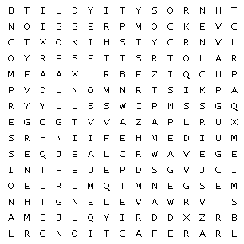

ACROSS  
1. ___________________ Lowest part of a wave  
2. ___________________ Close parts of a longitudinal wave.  
3. ___________________ Number of complete waves that pass a given point in a certain amount of time  
4.___________________ Highest part of a wave

5. ___________________ Waves that require a medium through which to travel  
6. ___________________ Material through which a wave travels.  
 7. A ___________________________ wave is a mechanical wave that travel perpendicular to an applied force.  
 8. ___________________ Mechanical Wave that moves the medium PARALLEL to the direction in which the waves travel.  
9. ___________________ The unit for frequency.  
10. ___________________ Crest to crest. Trough to trough. (Any point on one wave to the identical point on the next wave)  
11. ___________________ Distance from resting position to crest/trough  
 12. ___________________ Ability to do work  
 13. ___________________ Far apart parts of a longitudinal wave.  
 14.___________________ Disturbance that transfers energy from place to place